ANLY 501 Visualization Graphs

Team Member: Cheng Zhong, Tianyu Yang, Min Xiao

1. **Tableau**

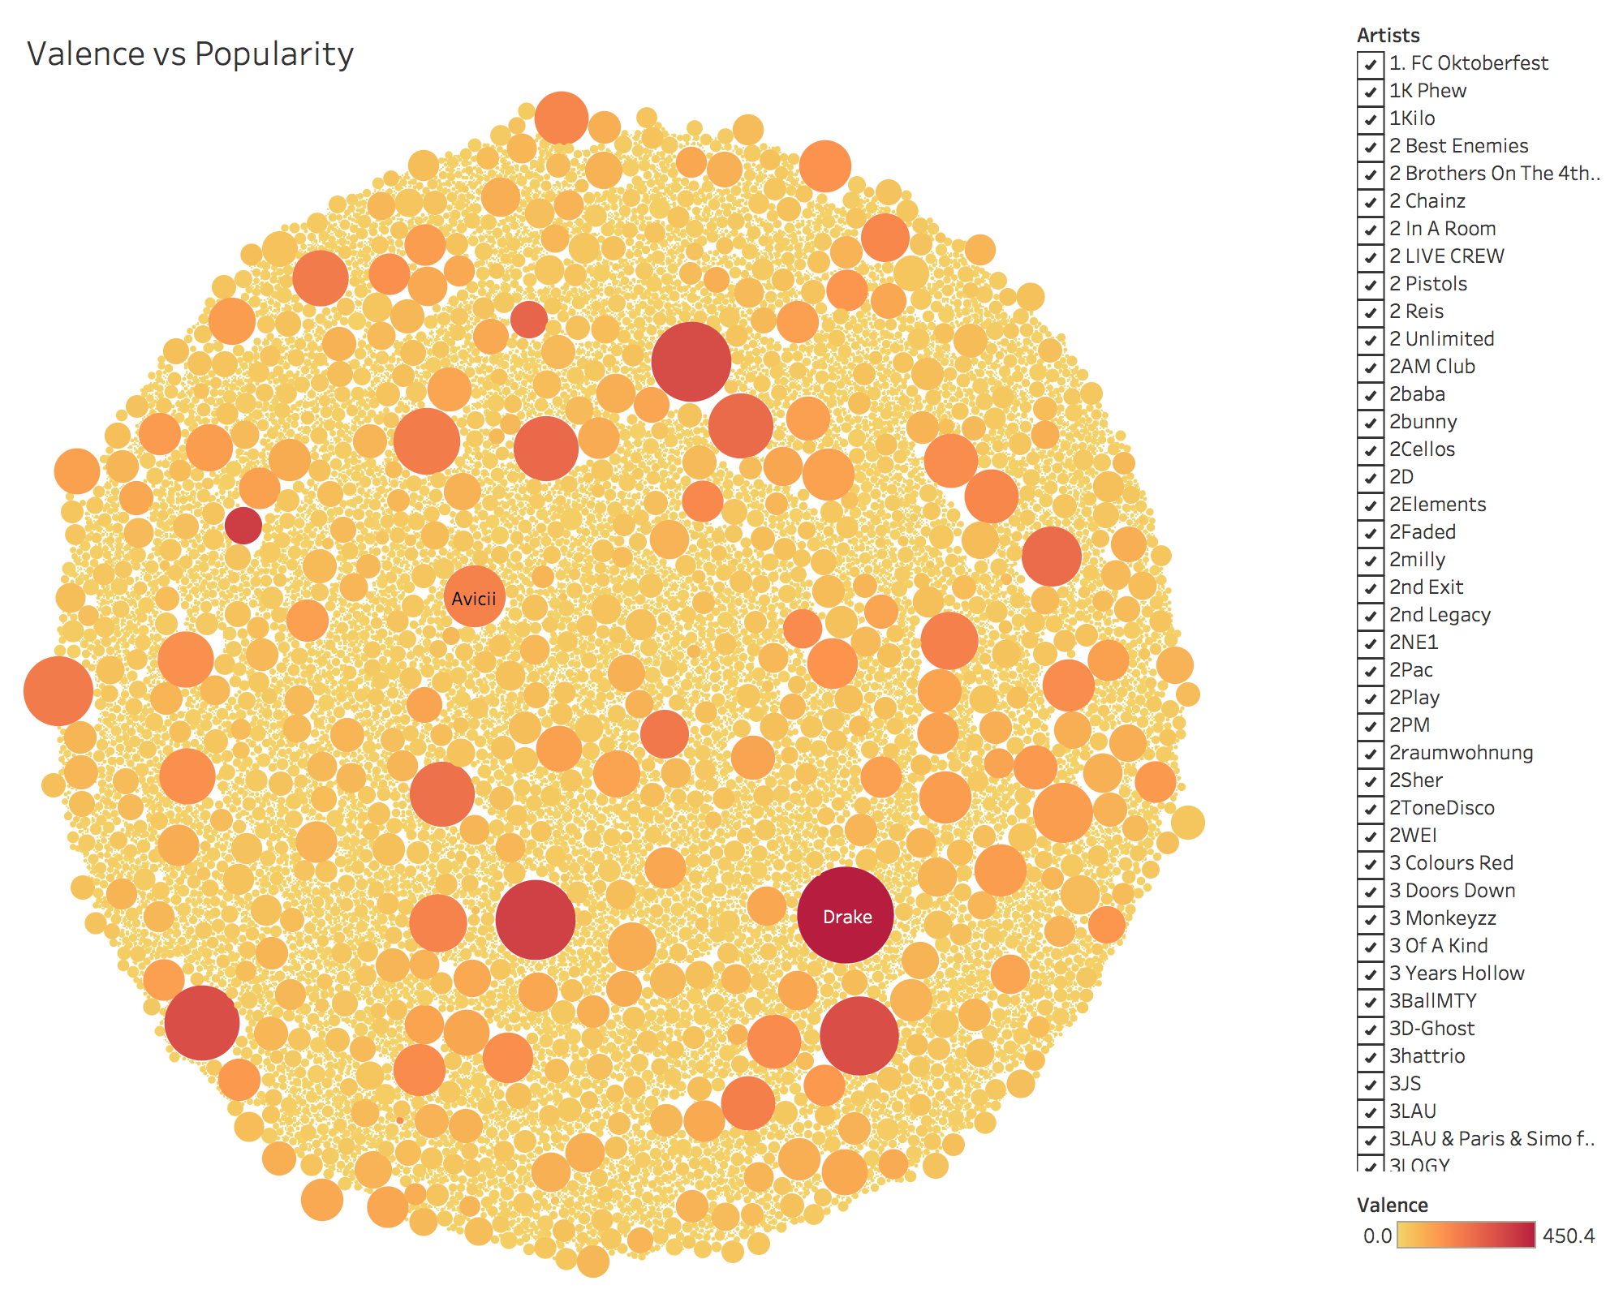

**Result**

As we can see that each circle represents an artist. The size of the circle indicates the popularity and the color indicated the valence of the artist. The plot indicates that those artists who has a higher valence score also has higher popularity.

1. **Tableau**

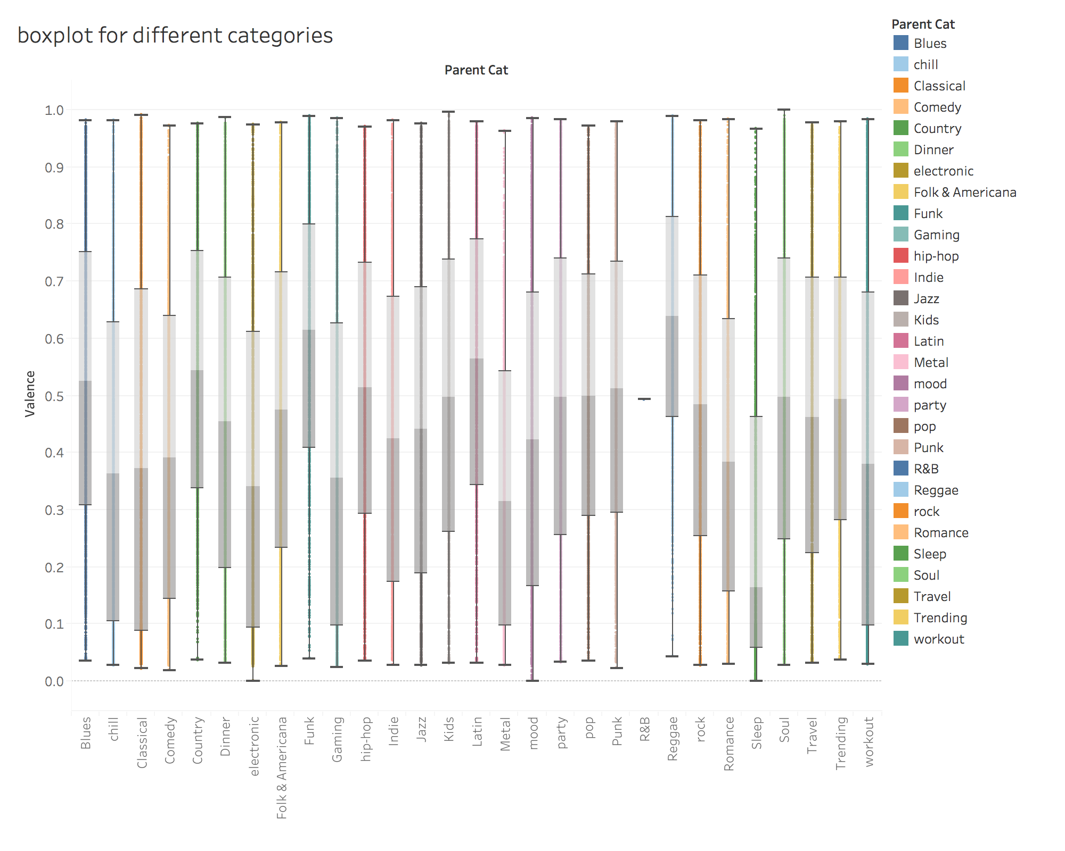

**Result**

The plot shows that different categories has different valence score. As we can see from the plot, some category is obviously larger than other category such as Funk, Country and Reggae.

1. **Word Cloud**

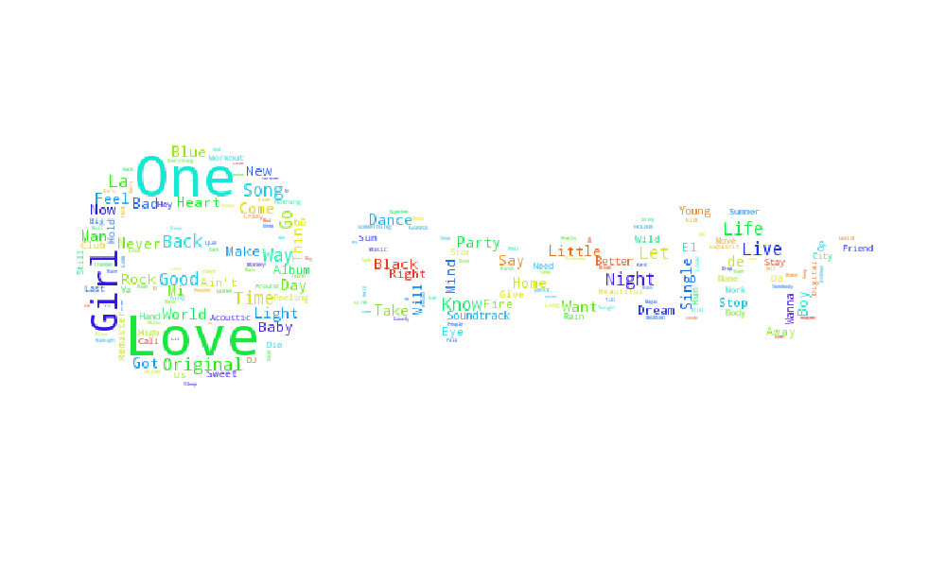

**Result**

Word Cloud for Song title in Spotify, obviously, love is the word shows up in song title most.

1. **Plotly**

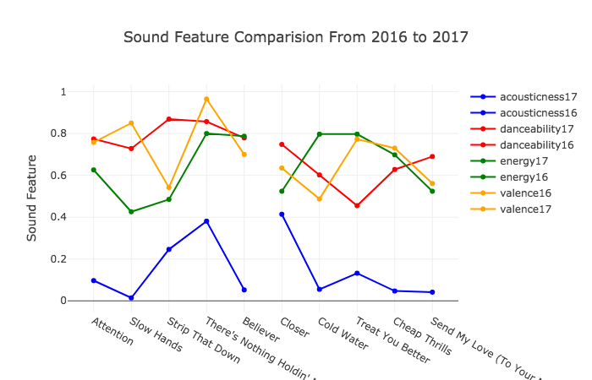

**Result**

The interval for valence and danceability slightly increased from 2016 to 2017. The result shows that people prefer happier songs in 2017 rather than 2016.

1. **Plotly**

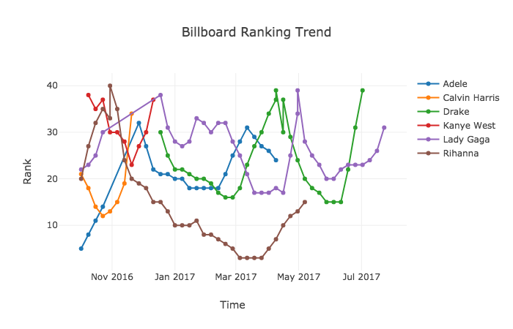

**Result**

Above is the ranking trend for hottest singers during 2016 to 2017. As we can see that these singers are keeping their ranking in top 50.

1. **Plotly**

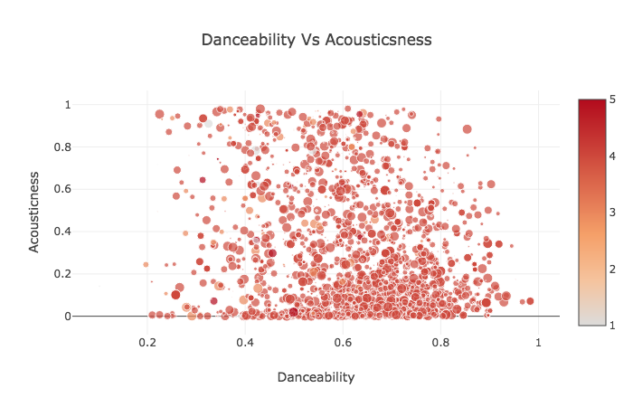

Bubble charts for Danceability vs Acousticness , there is approximately one cluster

1. **Plotly**

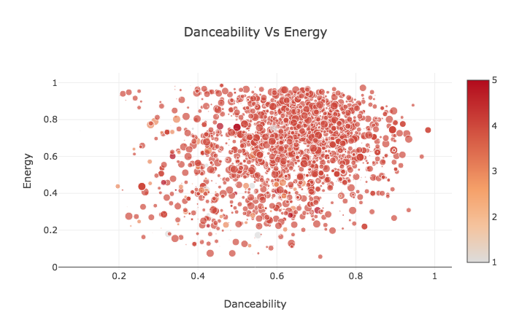

Bubble charts for Danceability vs Energy, there is approximately one cluster

1. **plotly**

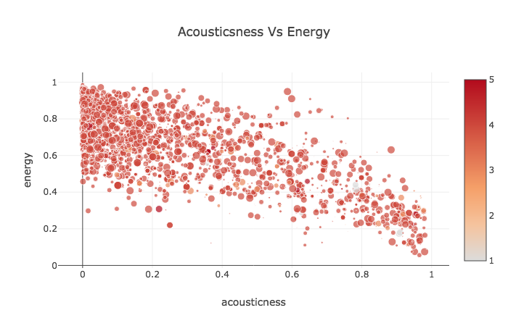

Bubble charts for Acousticness vs Energy, there is approximately one cluster. Also, there is an approximate linear relationship between acousticness and energy.

1. **Network**

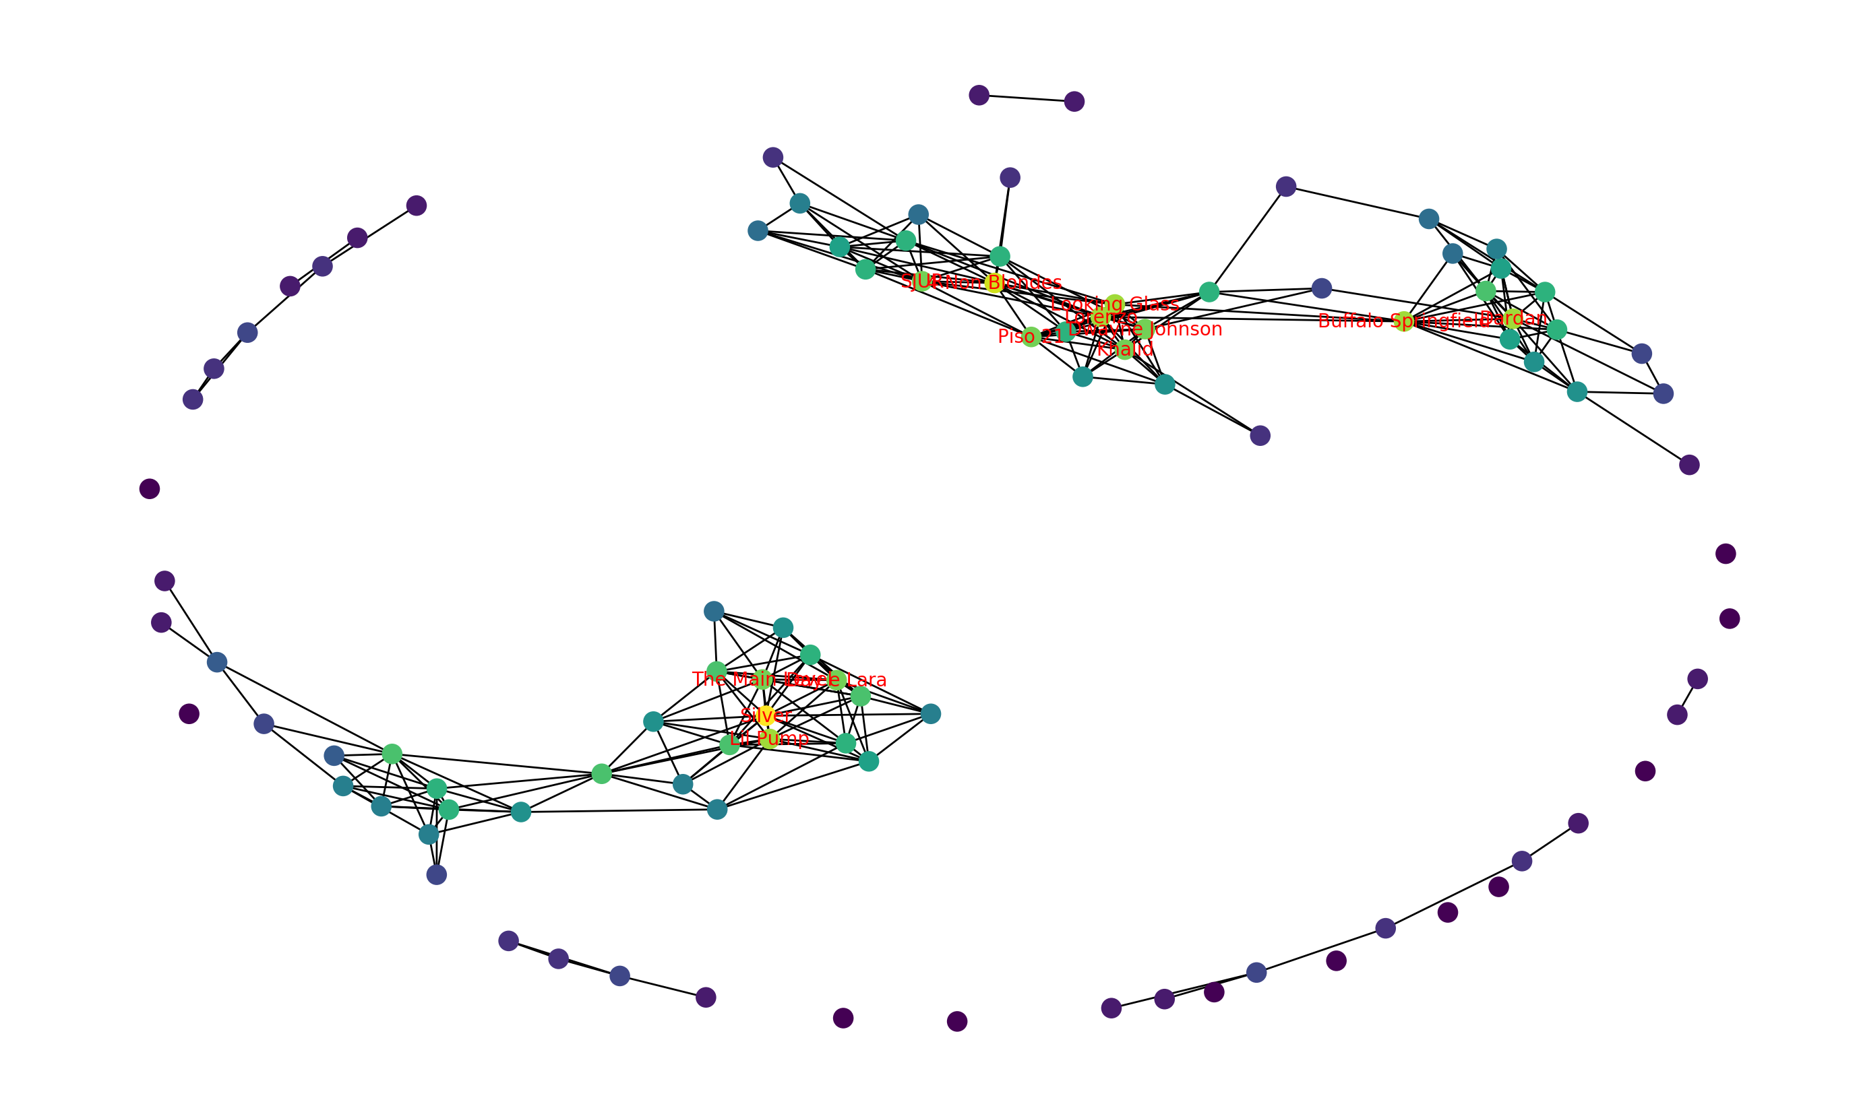

**Results**

While half of the nodes are not interconnected, the other half formed three densely connected networks. One interesting observation is that the three nodes with extremely high centralities are rock bands from the 60s to the 80s. They are 4 Non Blondes, an American rock band from San Francisco formed in 1989, Buffalo Springfield, Canadian-American rock band active from 1966 to 1968, and Silver, American rock band in the 70s. It is surprising that musicians from almost half century ago have so much connection with artists of various kinds in the later generation. Such connections and signs of heritage provide insights into modern music evolution.

1. **Cluster Analysis**

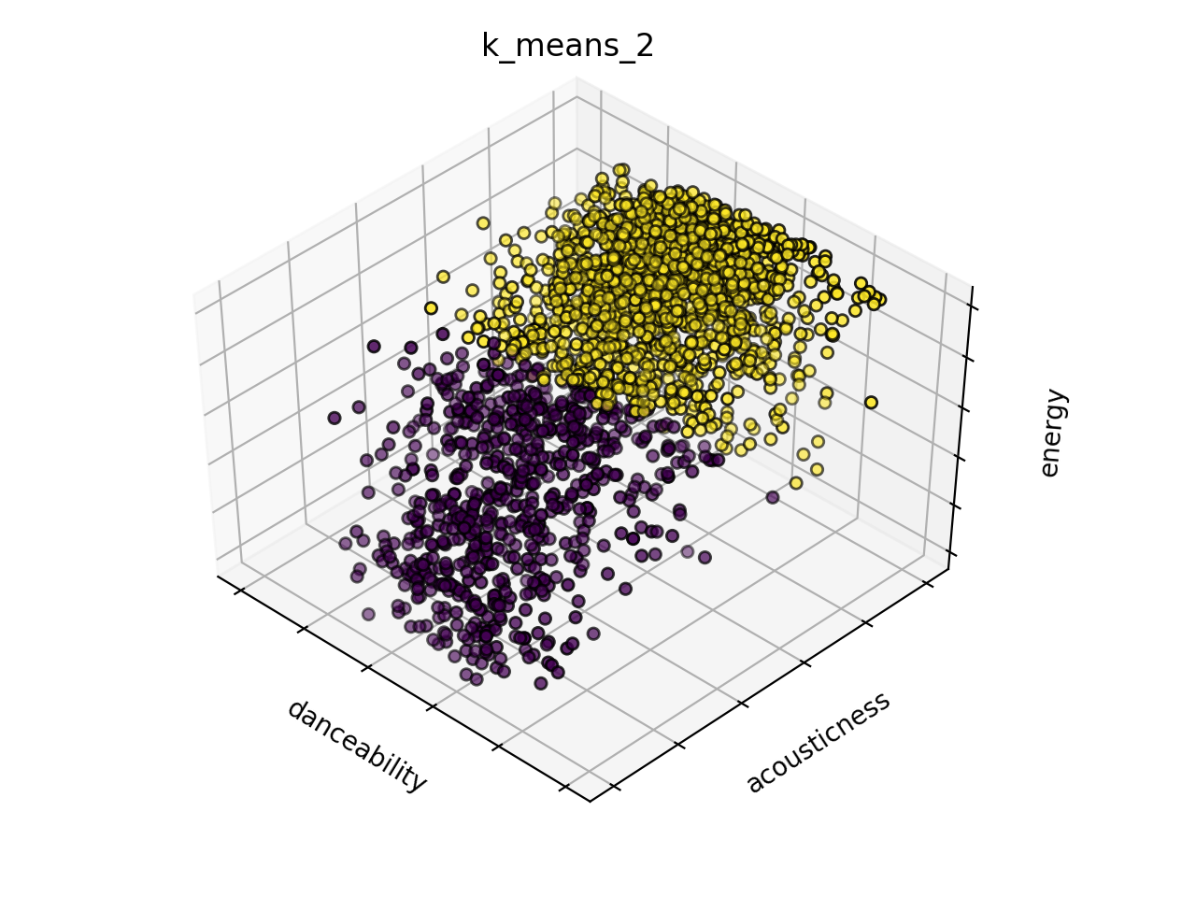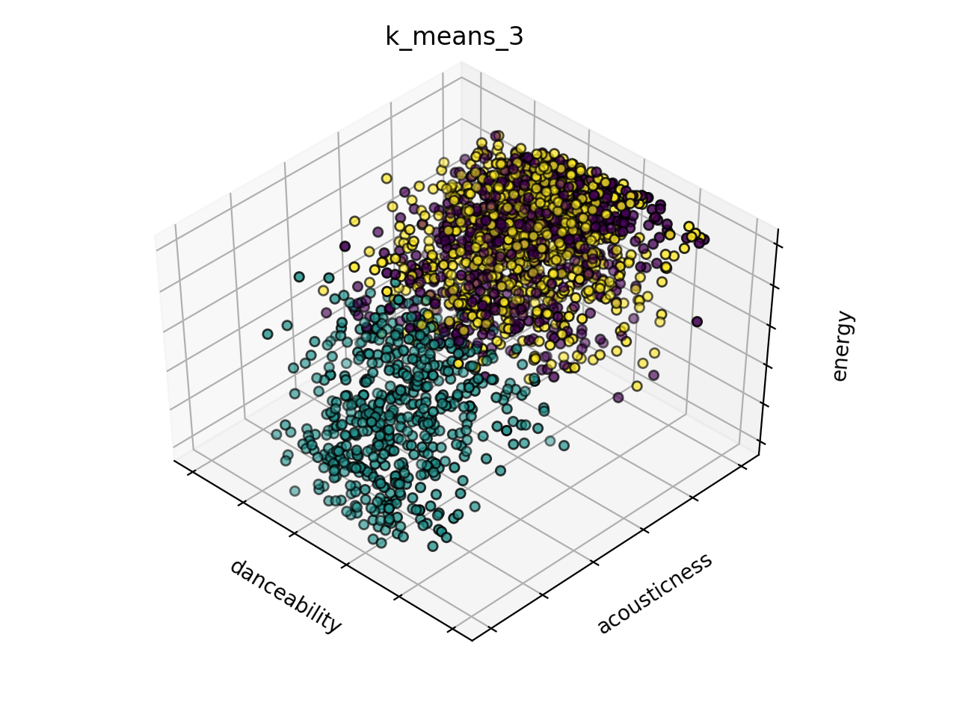

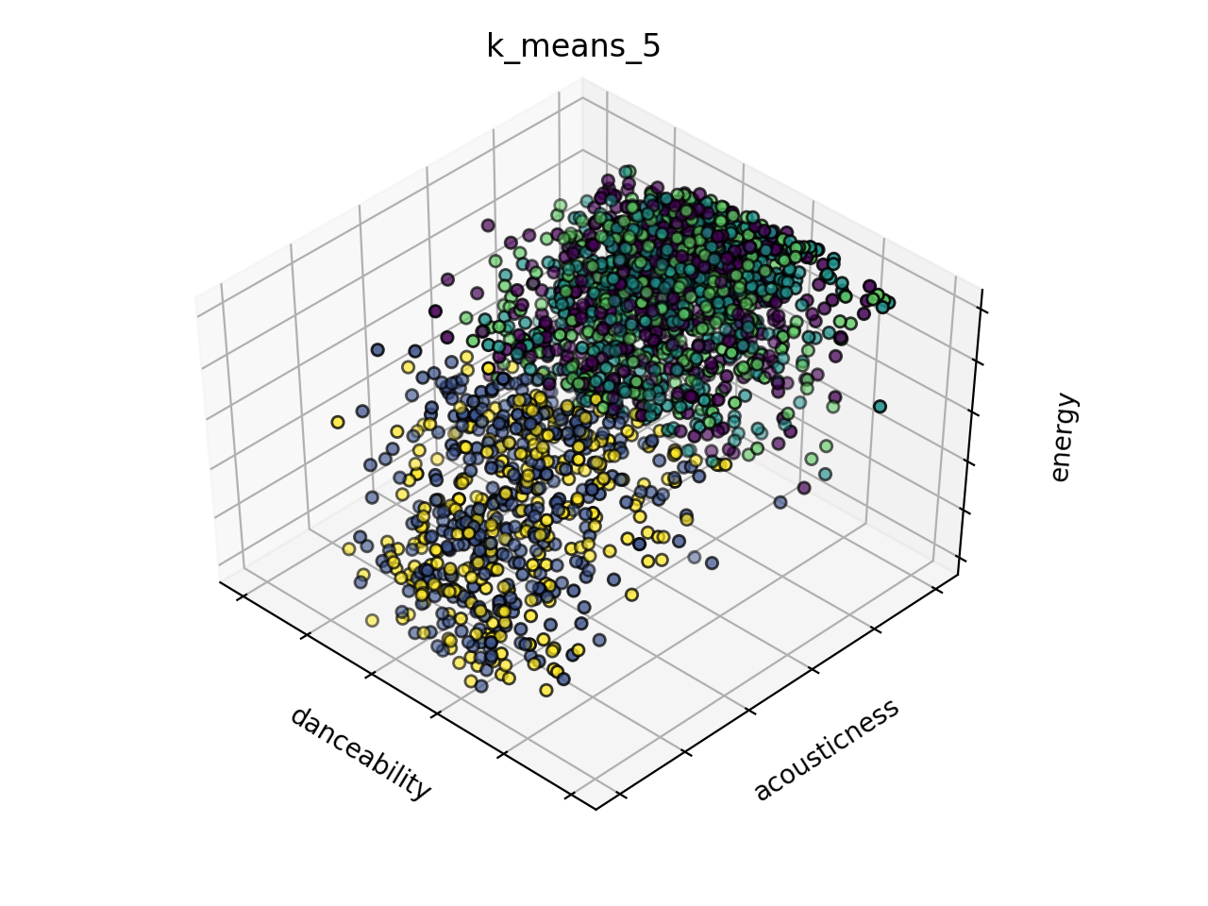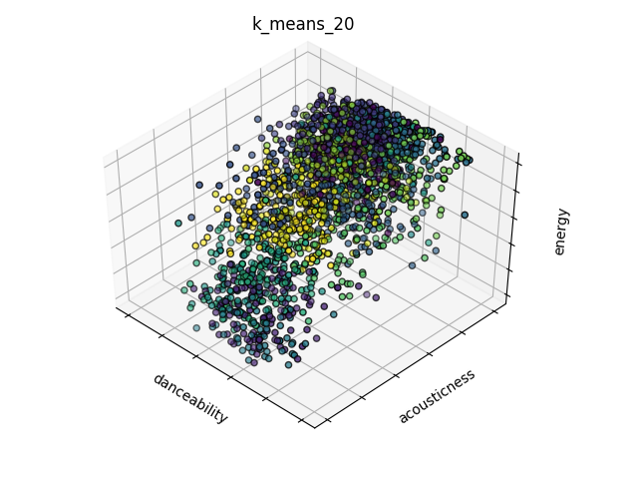

Overall, the data(“pop”) has weak subcategories. From the 3-D clustering plots, we observe two potential subcategories formed by songs with higher energy, danceability, and acousticness, and their counterparties.